Press release – May 4. 2015

CLIMATE: 39 NUCLEAR ASSOCIATIONS COLLABORATE

39 nuclear associations sign agreement

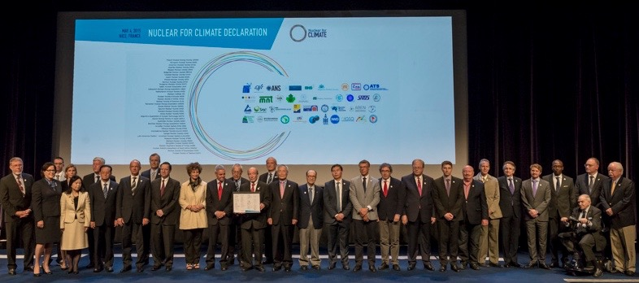
During ICAPP (International Congress on Advances on nuclear Power Plants) in Nice, France, 39 nuclear societies, representing 50,000 scientists from 36 countries from all five continents jointly signed a declaration that presents their commitment to the fight against climate change.
The declaration is a major component of the “Nuclear for Climate” global initiative to achieve recognition that nuclear is a low-carbon energy that is part of the solution to fight climate change. In the summer of 2014, nuclear engineers and scientists launched this grassroots initiative.
Initially launched through the French Nuclear Society, the European Nuclear Society, and the American Nuclear Society, the presidents or representatives from the participating organizations gathered today to declare, “We proudly believe that nuclear energy is a key part of the solution in the fight against climate change.”
The scientists and business leaders stressed that each country needs access to the widest possible portfolio of low-carbon technologies available, including nuclear energy, in order to reduce CO₂ emissions and meet other energy goals.

They call for the new UNFCCC (United Nations Framework Convention on Climate Change) Protocols to recognize nuclear energy as a low-carbon energy option, and to include it in its climate funding mechanisms, as is the case for all other low-carbon energy sources.

The French Nuclear Energy Society, SFEN (Société Française d’Energie Nucléaire) is the French knowledge hub for nuclear energy. Created in 1973, the SFEN provides a space where all those who are interested in nuclear energy and its applications can obtain and exchange information. The SFEN brings together 3 600 professionals, engineers, technicians, chemists, doctors, professors and students from industrial sites and from the French nuclear research organisations.

Press contacts :
Isabelle Jouette
01 53 58 32 10 - 06 71 92 23 95
isabelle.jouette@sfen.org

